Tunnel to Jerusalem

Picture of TBM 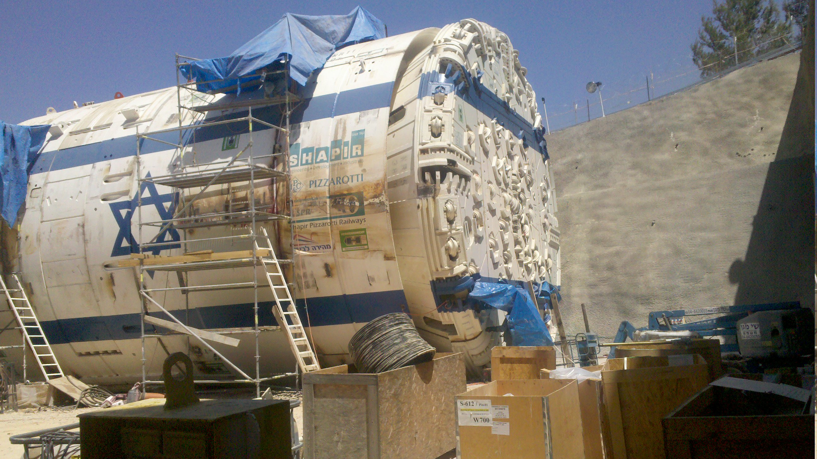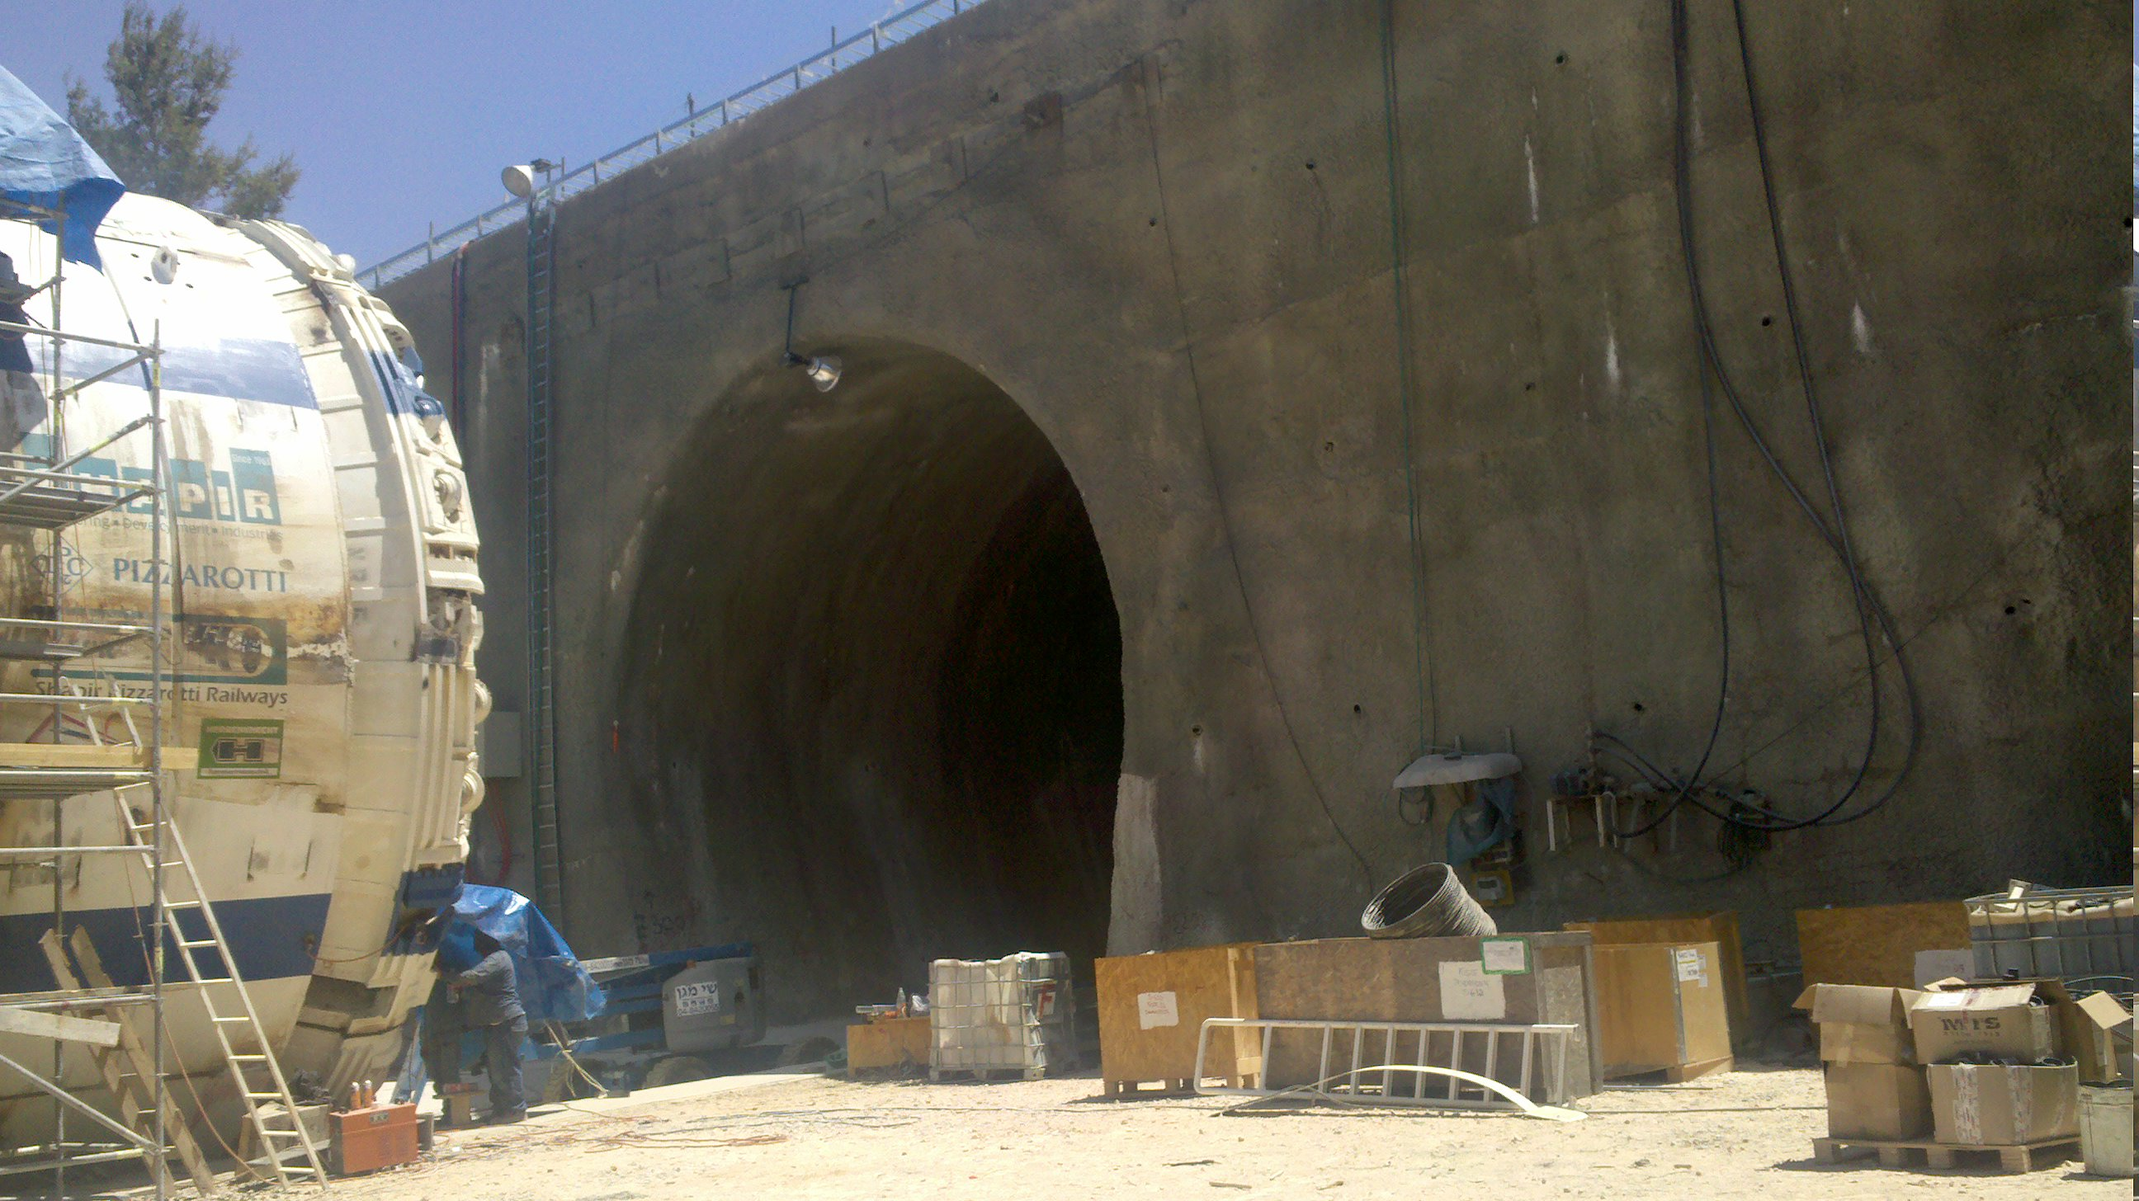

an existing motorway bridge and addition of a new bridge

Map of the tunnel location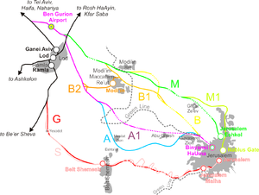

|  |  |
| --- | --- |
| General Data: | |
| **Project:** | The fast Tel Aviv - Jerusalem train’s railway section Latrun – [Sha'ar Hagai](http://en.wikipedia.org/wiki/Sha%27ar_HaGai) (Section B) under [Canada Park](http://en.wikipedia.org/wiki/Canada_Park) |
| **Client:** | **Minrav** in joint venture with Mosmetrostroj |
| **Delivery period:** | 2012 - 2013 |
| **Scope of work:** | High-speed railway line from Tel Aviv to Jerusalem   * 2 TBM-driven tunnels, length: 3,5 km each, external diameter 10,0 m, 3600 rings of 6+1 segments |
| Sealing method: | Maximum hydraulic pressure 5 bars, short rain events  Test pressure 9 bars at the worst combination of 4 mm gap and 15 mm offset  SANY0024TunnelFlex 33 Plus, Rubber gaskets with 90° Soft corners |
|  | TS 33x11 (8) PLUS E 106.wmf |
| **Additional information:** | ES Rubber Ltd. | Kibbutz Ein Shemer | M.P. Hefer 38816, Israel | +972.4.637.1037 | [export@esrubber.com](mailto:export@esrubber.com) | www.esrubber.com  Dr. Werner Grabe mobile +49 174 6884223 |

